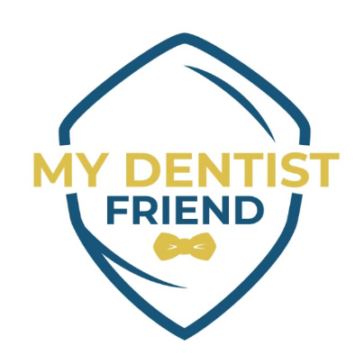 My Dentist Friend
Virtual Recruitment Event & Information Session October 8, 2026 - 12:30PM to 1:00PM
Now Hiring Dental Hygienist
Hosted by the NJ Department of Labor & Workforce Development
My Dentist Friend is hiring Dental Hygienist for Vineland, Millville, Sicklerville, and Audubon offices.
- Minimum of $52.00 to $60.00/hour
- Company matched 401K at 3%
- Paid Vacation, PTO, Sick
- $1,000 Sign-on Bonus

Come join this team of professionals offering great benefits and pay with the opportunity to grow your career pathway! Registration is required to attend.

Registration Link:
https://forms.cloud.microsoft/g/15M3vJeyx8
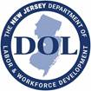Reference Job Order # DF1092802 